Housing Low-Income Populations in NYC

By: Orla Kelly

**Project Summary:** Throughout my project I aim to understand the ways in which different variables such as homeless shelters, landlord intimidation, and evictions relate to affordable housing for low-income population in New York City.

**Purpose & Background:** My research and compilation of data is relevant to the current de Blasio administration to better understand where underserved populations are located. In the same vain, it is my goal to examine how “successful” they have been in instituting their current “Housing NYC” plan. There are elements of the plan such as the relationship between homeless shelters and affordable housing which are made throughout the plan, yet some elements related to housing, which NYC failed to be recognize, such as: where evictions are located. Additionally this report aims to shed a light on the ways in which low-income populations are impacted by housing insecurity. Through examining the ways in which housing insecurity manifests will express to government systems the areas in which they are falling short. Additionally, it is my goal to express to all New Yorkers the challenges of housing all people.

In fall 2015, De Blasio released a plan to expand the shelter system and affordable housing in New York City (Housing NYC plan). The administration believes that this is because of the lack of affordable housing units in New York city (Housing NYC plan). Therefore the main purpose of this plan was to expand affordable housing.When thinking about affordable housing a lot of questions come up. Are people able to find housing in communities they are familiar with? Are there more evictions in places where there is more affordable housing? Are there enough homeless shelters to serve the needs of communities? How does landlord intimidation play into housing insecurity? How can we effectively house all people? These questions guided my research to better understand how different variables affect housing insecurity.

**Literature Review:**

The idea of an affordable housing crisis in New York is not new, most of what this crisis is attributed to is pure and simply lack of affordable housing. Yet throughout my research I aimed to examine the other ways low-income populations are being left behind.

Affordable Housing:

The key element of affordable housing is that a person should not need to pay more than ⅓ of their income towards housing. Although there is a lot of housing in and around NYC there is much less which would be considered affordable to families who are low-income which is the problem. In de Blasio’s plan aims to have 300,000 affordable housing units across NYC by 2026 (Housing NYC Plan). This means more development of affordable housing but also maintaining rent-stabilized units, and other programs throughout the city which are eager to capitalize on the market-rate costs for housing (Housing NYC Plan).

Evictions & The Speculation Watchlist:

In 2018 a speculation watch-list was created by the city of New York as a tool to understand why there has be a decrease in rent-regulated units . The law reports when multiple rent regulated units, become unregulated or can be sold at the market value due to vacancy (NYC Local Law). The city of New York recognized these patterns as possible tenant intimidation, because when a tenant leaves their unit something called “vacancy decontrol” occurs, in which the unit can be sold and utilized at the market rate (NYC Local Law). This informal eviction happens through actions such as intimidation and other non-traditional measures.

This intimidation can be seen through a variety of different ways and mediums. For example, the neighborhood above the Manhattanville campus is “Hamilton Heights”. One community member describes the intimidation as constant construction which involved dust, noise (Kim). Yet to make matters work the construction impacted the people living there things such as lack of cooking gas, ceilings falling were not uncommon (Kim). These repairs for tenants currently living there were often ignored (Kim). the Manhattanville campus open the property surrounding the area is going up and landlords are eager to tap into new markets which had not previously been seen in these communities.These are just some of the ways landlords aim to kick out their tenants with informal measures. Although the connection between informal evictions and the speculation watch list is a broad one, it is likely that landlords had some influence over tenants which would allow them to vacate their rent regulated units.

Homelessness:

An element of de Blasio’s plan is to create 90 new homeless shelters, as a mechanism to connect people to shelter and ultimately housing. Although New York has a “right to shelter” law, currently shelter connects private enterprises such as hotels and private apartments to individuals which allows individuals be housed whenever they don’t have shelter. Although these mechanisms allow people to have shelter it fails to connect them to services which are most often found in shelters. Additionally shelters have resources available to connect people to housing that they can receive (DW Gibson). Therefore the expansion of the shelter system will ultimately connect more people to affordable housing. An element of this expansion is to have more shelters in places where people have a community ties, jobs, family and friends.

**Limitations:**

Although there is a lot of data and information about the affordable crisis in New York, it is impossible to know the best way to “solve” this problem. Similar to the de Blasio Housing NYC plan I thought that it was critical to examine different elements of the housing crisis because there are a variety of different stories which ultimately lead to housing instability. Although there are statistics about numbers of affordable housing units, shelters, homeless populations, evictions, on a short-time scale it is difficult to know and understand what policies are working, what data is important, and how to most adequately use our resources.

**Data:**

NYC Open Source

i) Department of Housing Preservation & Development

1. Housing New York Units by Project: A count of affordable housing units after 2014 when the Housing NYC plan was created & instituted.
2. Speculation Watch List: Multiple rent-stabilized dwellings in a building, becoming market value.

ii) Social Services

1. Individual Census by Borough, Community District, and Facility Type: Describes the number of individuals in the shelter system by census tract.

iii) City Government

1. Evictions: A count of the amount of evictions in NYC from 2017 to present day.

**Methodology:**

Throughout my research I was very overwhelmed by the variables associated with affordable housing. But through my research I aimed to make connections between affordable housing units and other relevant variable such as homeless shelters, evictions, and the speculation watch list. By dividing my project into different variables I found it easier to understand the ways in which low-income people are housed.

Additionally I found data on NYC open source which allowed me to make connections between cross-department data. All of the shapefiles I found was for the most part by address and due to the scale of my project I thought it was important to look at New York as a whole rather than individual communities. For this reason I had to sum the data to make a choropleth map rather than a point based map, such as in figure 1 to show evictions. I did this so that I would be able to include other data such as the amount of affordable housing unit through scaled points.

In figure 2 I was able to use graduated points to express how many homeless shelters were in each community district. I used graduated points because it allowed the viewed to to see the scale/magnitude of the amount of homeless shelters in a particular community district.

While in the creation of figure 3 I only included Manhattan and the Bronx due to the fact there was a lot of missing data. I used the same shapefile I had used for mapping by zip code but in an editing session I selected Kings (Brooklyn), Queens, and Richmond (Staten Island) counties to delete due to the fact there was no data. Additionally similar to figure 1, I had to sum the amount of properties within a giving zip code so that I could create a choropleth map. After examining the information and data in this map I thought that it was important to specifically examine the neighborhood of Hamilton Heights to show how and where specific properties where on the speculation watch list, to see if it would be in close proximity to the new Manhattanville campus.

**Findings:**

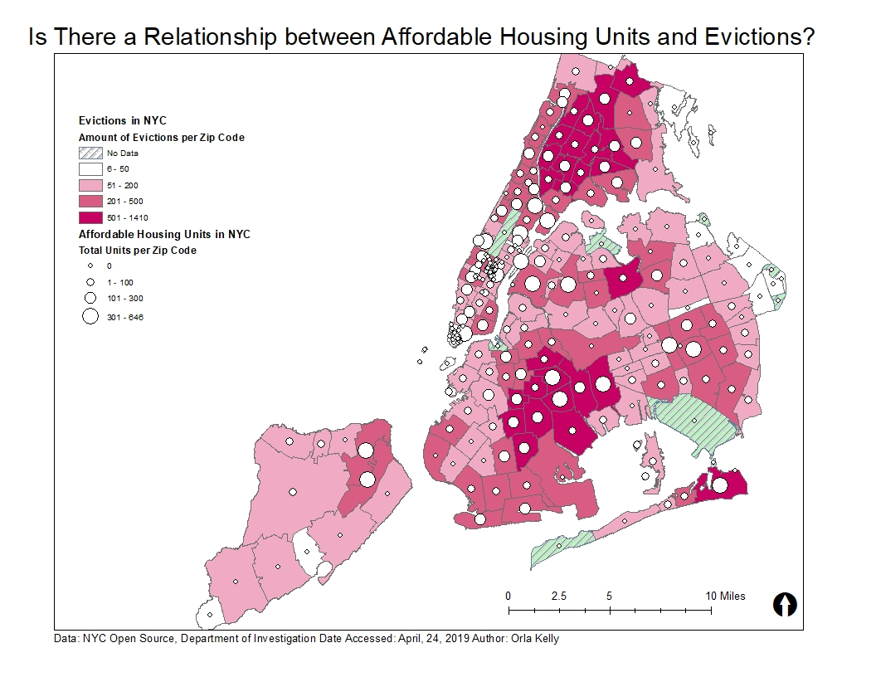

*Figure 1*

This map utilized data found in NYC open source, specifically the department of investigation and the department of housing development and preservation. Through the expression of this data in map form I wanted to understand if there was a relationship between affordable housing units for low-income populations and the amount of evictions per zip code. Through the making of this map it seems as though there is very little relationship if any at all between the expansion of affordable housing and where evictions occur. This surprised me because I assumed the expansion of affordable housing would be in places where people can no longer afford to live and therefore get evicted.

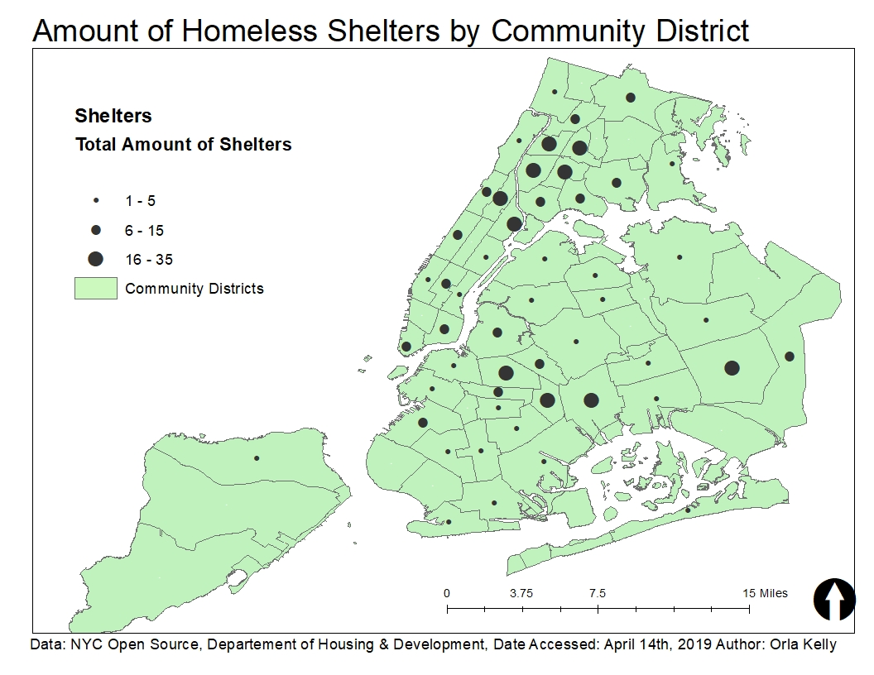

*Figure 2*

This map expresses where the homeless shelters tend to be distributed. From this map it is easy to see the majority of shelters lie within the south Bronx and northern Brooklyn. When comparing to *Figure 1* it is obvious to see that there are a concentration of shelters in places where evictions are more likely to occur. Yet is interesting that affordable housing is not concentrated in the areas with the most need rather based on the data seem to be distributed throughout the city.

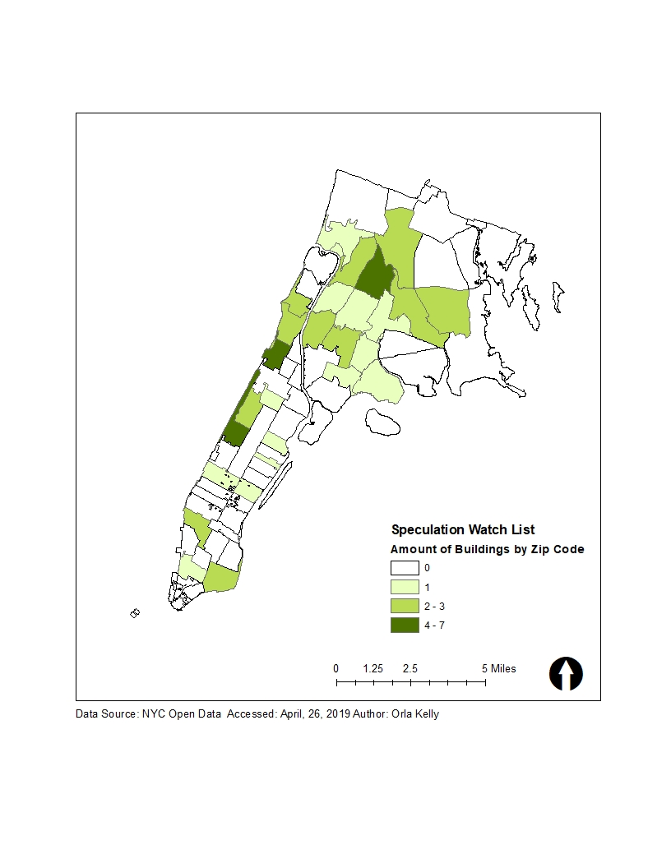

*Figure 3*

The speculation watch list is a mechanism to identify landlord intimidation, this relatively new data source released by the department of Housing & Preservation, aims to hold landlords accountable in addition, to considering where people are at the most risk for being forced out of their homes. Although the New York City Department of Housing and Preservation has not released a lot of data on this topic (only in the Bronx and Manhattan) there seems to be a cluster of eviction in the Bronx in addition to the Upper West Side and Hamilton heights. The fact that landlord intimidation is spread among many zip codes shows that there are neighborhood changes are everywhere rather than in one broader region

Hamilton Heights Speculation Watch List

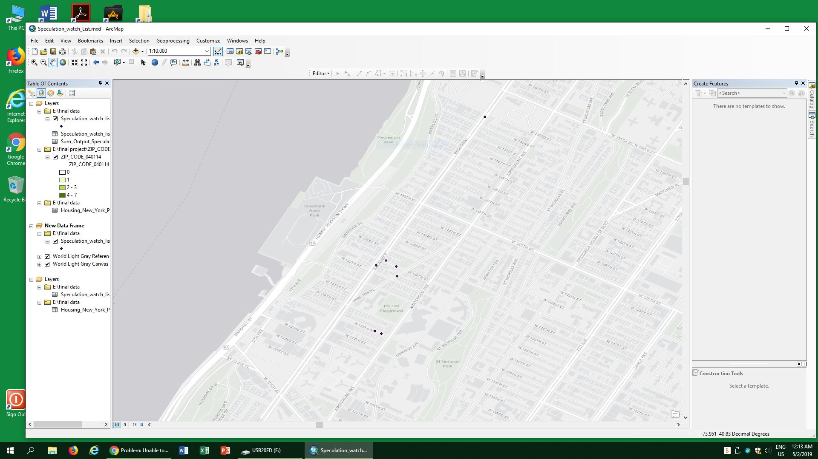





*Figure 4*

This map shows a close up of what properties are suspected of landlord intimidation. This zip code had the most properties suspected of landlord intimidation (7). The majority of the properties fall within 135th st and 141th, which is relatively close to the new Columbia Manhattanville campus. The high amount of properties in the area which are suspected of landlord intimidation could be because of the expected increase in land-value in the next few years due to the expansion.

**Limitations:**

The biggest limitation throughout the creation of this project was the areas without data specifically, the speculation watch list which did not yet have data available. Additionally, my broad scope of my project presented a limitation to try and understand what the most important data was to include in this project. Additionally, I made a connection between landlord intimidation and the speculation watch list but there is no specific evidence for intimidation for specific buildings. Rather the speculation watch list is a way to hold buildings accountable and to question why so many stabilized units are becoming unstabilized. Yet ultimately, I was able to include all of the data and information which was relevant to this project.

**Recommendations and Conclusions:**

Through the use of maps, it is possible to conclude that in places with high evictions there are more homeless shelters which makes sense. These places include the south Bronx and north east Brooklyn. Although it is obvious to see the trends in these places there seems to be little to no link between the amount of affordable housing units in these areas. For this reason, I would recommend that the city should create more affordable housing in communities where people are being evicted, due to likely a large part of their eviction challenges is not being able to afford rent. By expanding affordable housing in these regions would allow for people to live in places where they had previously lived, have family members or work.

In addition to an expansion of affordable housing in these regions I would recommend more data surrounding the speculation watch list. This could allow families to know and understand the challenges they could face in the future, in addition to, understanding that they are not alone. Additionally, it could prepare them for possible landlord intimidation. There is information to better understand these challenges such as the Association for Neighborhood & Housing Development which express where high-risk displacement buildings are located. The distribution of this information is critical to holding landlords accountable and keeping tenants safe within their homes. Ultimately the expansion of both reliable accurate information and affordable housing in high-need areas is critical to solving the affordable housing crisis in New York.

**Bibliography**

Housing NYC Plan (2014) <https://www1.nyc.gov/assets/housing/downloads/pdf/housing_plan.pdf>

Local Laws City of New York No. 7 (2018) <https://www1.nyc.gov/assets/hpd/downloads/pdf/about/ll7-of-2018.pdf>

Kim, J. (n.d.). Inside Manhattanville Tenants' Fight Against Predatory Landlords. (February 21 2018) Retrieved from https://www.columbiaspectator.com/eye/indirect-displacement-manhattanville/

Gibson, D. W. (2017, March 22). Why It's So Hard to Stop Being Homeless in New York. Retrieved from http://nymag.com/intelligencer/2017/03/nyc-homelessness-crisis.html